DETERMINATION OF THE STATUS OF WATER QUALITY IN THE SADDANG RIVER BY THE POLLUTION INDEX METHOD

Reni Oktaviani Tarru#, Sumbangan Baja*, Farouk Maricar* Rita Tahir Lopa *
#Doctoral Student of Civil and Environmental Engineering, Hasanuddin University, Makassar, INDONESIA
E-mail: renioktavianitarru1810@gmail.com
*Department of Soil Science,Faculty of Agriculture, Hasanuddin University, Makassar, INDONESIA
E-mail: sumbanganbaja02@gmail.com
* Department of Civil and Environmental Engineering, Hasanuddin University, Makassar, INDONESIA
E-mail :fkmaricar@yahoo.com
* Department of Civil and Environmental Engineering, Hasanuddin University, Makassar, INDONESIA
E-mail :ritalopa04@yahoo.com
Abstract— One source that has the potential to pollute the Saddang river is the existence of a livestock trading center. The Trade Center produces liquid waste which is directly discharged into the river without going through any treatment first, this has a great potential to pollute the Saddang river. The purpose of this research is to know the level of pollution of the Saddang River which can be seen from the status of the water quality. In this study, the method used is the Pollution Index (IP) method. The use of this method refers to PP No. 82 of 2001 concerning the management of water quality and control of water pollution and the Decree of the Minister of the Environment No. 115 of 2003 concerning the status of water quality. In principle, the IP method uses a determined weight because the allocation/benefits of the river are in accordance with its segment. This research was conducted on five segments on the Saddang River. River water quality parameters used include: temperature, TDS, pH, DO, BOD, COD, nitrate, Nitrite, Total Coliform, E-Coli. The water quality data obtained in each segment are then analyzed for each segment. The results of calculations using the IP method obtained that the water quality status is relatively constant for each sampling, which is heavily polluted.
Keywords— Saddang River, liquid waste, Pollution Index

1.LITERATURE REVIEW

- Clean Water Standards

Water used daily for bathing and washing purposes must meet the Clean Water Quality Standards, while drinking water must meet the Drinking Water Standards based on the Government Regulation of the Republic of Indonesia Number 82 of 2001 concerning Water Quality Management and Water Pollution Control [1]. The main problems faced by water resources include the quantity of water that is not able to meet the increasing demand and the decreasing quality of water for domestic purposes, industrial, non-domestic activities and other activities that have a negative impact on water resources, causing quality to decline. its management is by monitoring and interpreting water quality data including physical, chemical and biological quality. Water quality states the level of suitability of water to be used for certain fulfillment of human life, such as for drinking water, irrigating crops, drinking livestock and so on. One of the strategic water resources potenctial and widely used for various development activities is river water. Given that rivers are important water resources to support economic development and human welfare, the function of rivers as water resources must be preserved in order to support sustainable development.

- Pollution Index (IP) Method
Pollution Index (IP) is determined for a designation, then it can be developed for several purposes for all parts of a water body or part of a river (Minister of Environment Decree No. 115 of 2003) [2]. Management of water quality on the basis of this Pollution Index (IP) can provide input to decision makers so that they can assess the quality of water bodies for a designation and take action to improve quality if there is a decrease in quality due to the presence of pollutant compounds [3].
${PI}_{j}= \sqrt{\frac{{ (C}_{i}{/L}_{ij})_{M}^{2}+ C_{i}{/L}_{ij})_{R}^{2}}{2}}$………(1)
Where:
Lij = concentration of water quality parameters listed in the Quality Standard of a Water Designation (j),
Ci = concentration of water quality parameters (i) obtained from the analysis of water samples at a sampling location from a river channel, Measurement Results
PIj = Pollution Index

3.Wastewater
Waste water is waste water originating from community settlement activities, households, restaurants, offices, commerce, apartments, campuses, dormitories, industry, ground water, surface water and other wastes (Metclaf & Eddy, 2004) [4]. Liquid waste treatment aims to remove or set aside contaminants. Contaminants can be in the form of organic compounds expressed by the value of BOD, COD, nutrients, toxic compounds, pathogenic microorganisms, non-biodegradable particles, suspended or dissolved solids [5]. Liquid waste treatment can be classified into three methods, namely physical, chemical and biological treatment. The application of each method depends on the quality of the effluent and the conditions of the facilities available [6].
Overview of Research Sites
This research was conducted in Tallunglipu Matallo Village, Tallunglipu District, North Toraja Regency, Sulawesi Province in the Saddang Watershed, sample testing at the Productivity and Water Quality Laboratory, Faculty of Marine Sciences, Marine Sciences and Fisheries, Hasanuddin University Makassar.
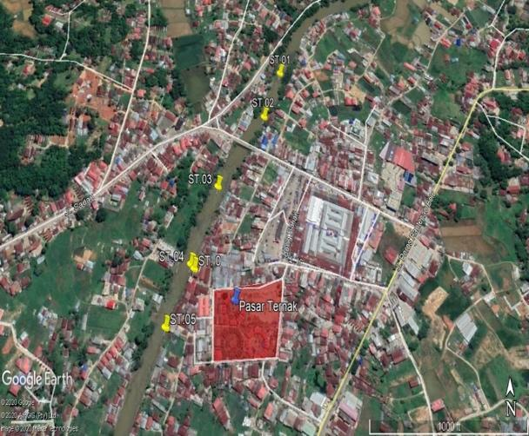
Fig. 1. Research location (Google Earth, 2020)

4. Sampling
Sampling of river water was carried out at 6 points consisting of points ST.01, ST2, ST.03 which were upstream and points ST.04-ST.05 were downstream when viewed from the animal market and ST.0 was at the waste outlet. . The coordinates and distances from each sampling point use the ArSurvey123 application as listed in table 1
Table 1. Coordinates of Sampling
NO. | X | Y
ST 1 | 119°54'44.149"E | 2°57'25.569"S
ST 2 | 119°54'42.776"E | 2°57'28.823"S
ST 3 | 119°54'39.185"E | 2°57'33.597"S
ST 4 | 119°54'37.403"E | 2°57'38.159"S
ST 5 | 119°54'36.459"E | 2°57'39.163"S
ST 0 | 119°54’37.670”E | 2°57’38.394”S
(Source: Reni Oktaviani Tarru, 2021)
The distance between sampling is ±100 meters for each sample point in the river and ST.00 is the outlet of waste from the animal market which directly enters the river with the Saddang watershed with a river width of 35 m, which is 64 m from the livestock market. The laboratory consists of Temperature, TDS, pH, DO, COD, BOD, NO_2 ,〖 NO〗_3 , E.Coli and Total Coliform, as shown in Figure 2.
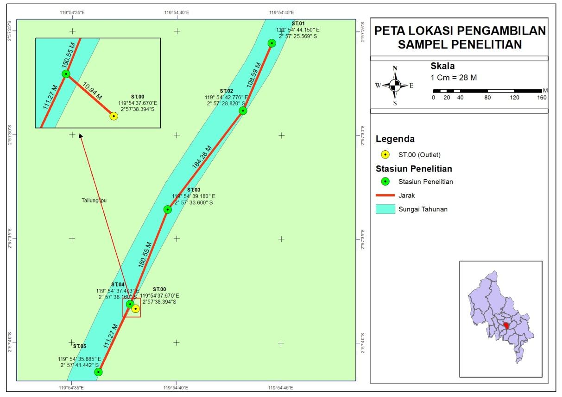
Fig 2. Map of Research Sampling Locations

5. Results and Discussion
Determination of Water Quality Status by Pollution Index (IP) Method
Based on the Pollution Index Method, it can be calculated after all the pollutant parameters of the Saddang River water are tested in the laboratory. IP method where the value of each parameter is compared with its quality standard as presented in table 2.

Table 2. Results of Water Quality Status at Stations (ST.01-ST.05) with Pollution Index.
Point | Upstream Distance (m) | IP Score | Quality Status
ST.01 | 0 | 11.79 | Heavy Polluted
ST.02 | 108.59 | 7.28 | Moderately Polluted
ST.03 | 292.85 | 6.34 | Moderately Polluted
ST.04 | 443.4 | 10.74 | Heavy Polluted
ST.05 | 554.67 | 12.17 | Heavy Polluted
(Source: Reni Oktaviani Tarru, 2021)
The calculation results obtained where the status of water quality along the Saddang River at ST.01 which is upstream is heavily polluted, ST.02 station which is upstream is moderately polluted, ST.03 station which is upstream is moderately polluted, ST station is moderately polluted. .04 and ST.05 which were in the downstream were heavily polluted and ST.00 which was at the outlet was also proven to be heavily polluted. Based on the IP results, there is a similar trend where the level of pollution in ST.00, ST.04 and ST.05 is heavily polluted as shown in Figure 3.
Fig 3. Graph of Pollution Index Value
6. CONCLUSION
The calculation results obtained where the status of water quality along the Saddang River at ST.01 which is upstream is heavily polluted, ST.02 station which is upstream is moderately polluted, ST.03 station which is upstream is moderately polluted,.04 and ST.05 which were in the downstream were heavily polluted and ST.00 which was at the outlet was also proven to be heavily polluted. So Need To Build Waste Treatment Before Entering The River Board
7.References
[1] Anonymous, 2001, Government Regulation of the Republic of Indonesia Number 82 of 2001, concerning Water Quality Management and Water Pollution Control.
[2] Anonymous, 2003, Decree of the Minister of Environment No. 115 of 2003 concerning the status of water quality.
[3] Lussya Setya dewi, Intan Subraba 2020, Determination of water quality status of sermo reservoir with STORET method and Pollution Index, Journal of environmental science and technology

[4] Ulfah Sarach Sheftiana, Anik Sarminingsih, Winardi D Nugraha.2017, Determination Of River Water Quality Status Based OnPollution Index Method As Control Environmental Quality (Case Study: Gelis River,Kudus District, Central Java), Journal of Environmental Engineering, Vol. 6,No. 1
[5] Metcalf & Eddy, 2004, Wastewater Engineering, Fourth Edition, McGrraw-Hill Inc., New York
[6] Reni Okaviani Tarru, Harni Eirene Tarru, 2016, Analysis of Sadang River Water on the Water Quality of North Toraja PDAM, Proceedings of Water Resources Converence, Surabaya
[7] Reni Oktaviani Tarru, Ermitha Ambun, Zulia Prihartini, 2018, Integrated Water Resources Management Patterns in North Toraja Regency, Proceedings of the HATHI Converenvce, Medan
[8] Agus Maryono, 2013, Management of Riverside Areas, Yogyakarta, Gadjah Mada University Press, 2018, ISBN 978-979-420-874-8

